Fruit Ninja Game

We have put all our efforts in this project to apply the OOP concepts we have learned along this semester and to ensure that we have understood the design patterns well and also to have a further practice on GUI .

upon starting the game , you will find the menu shown below .

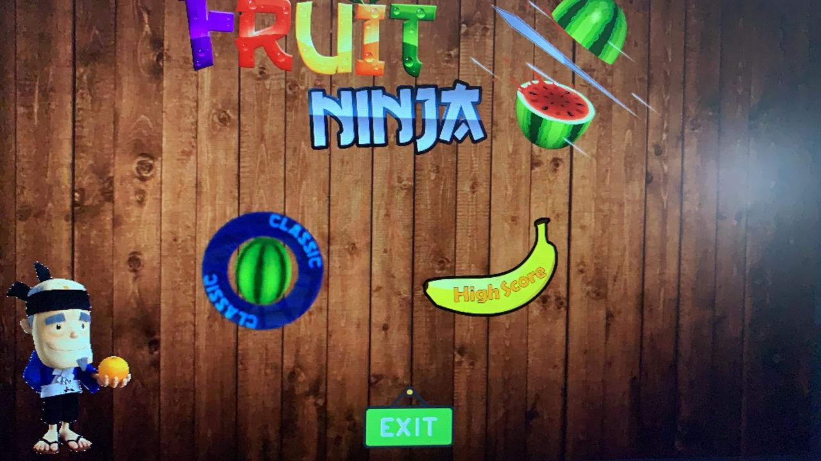

The menu is really simple , you have 3 choices you can choose by clicking on one of them with the mouse left click , if you click on the classic which has the watermelon shape you will be directed in to the game , an other choice which is the highscore that is shaped as a banana will direct you to highscore screen.

The 3rd choice is the exit button which is used to close the game.

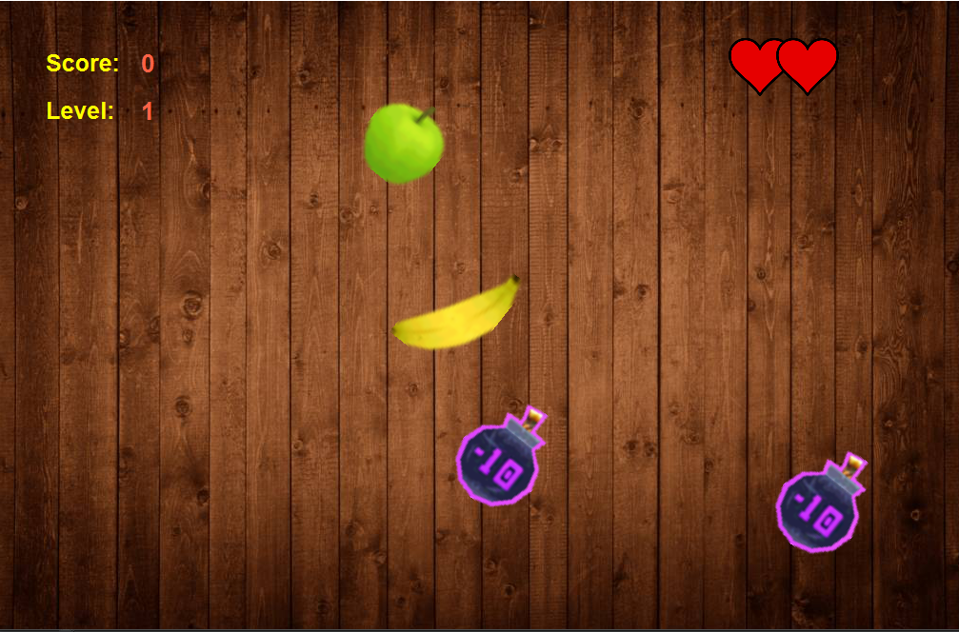

The show screen above is the game screen . the objective is to slice the fruits before the fall and to avoid bombs , you slice the fruits by moving the mouse cursor towards them without clicking any buttons, you gain one point for each fruit you slice , you have three hearts shown on the upper right of the screen in which you lose a heart every time a fruit falls without being sliced or when slicing a bomb,If you lose the 3 hearts it’s gameover. When you slice a ceratain number of fruits you advance to the next level where you will find less fruit and more bombs.

Your score and level are shown on the upper left of the screen

There are two types of bombs.



this bomb if sliced you lose one heart.



But this one is a special bomb , if you slice this bomb it’s gameover for you.

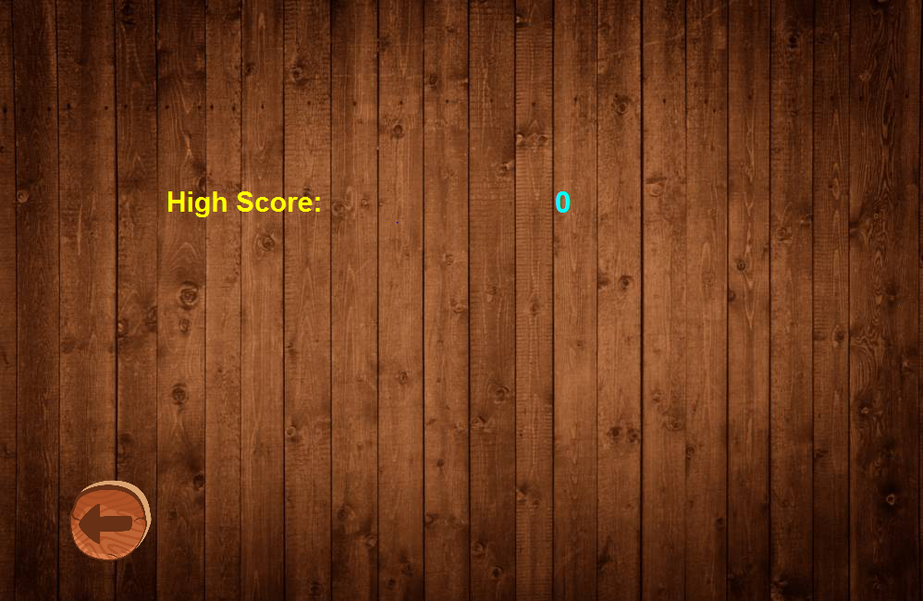

This screen above is the highscore screen where you can view your highscore.

On the lower left corner is a back button that can return you to the main menu.

Finally we want to thank all the staff for dedicating their time and efforts to help us understand this subject and for guiding is through java and the OOP paradigm.